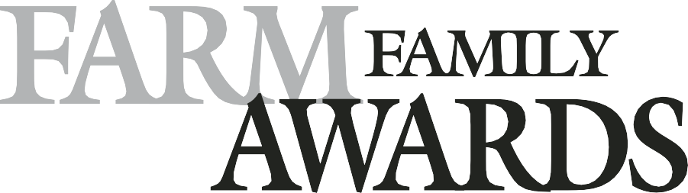

Submission Guidelines & Nomination Form

Municipal District of Greenview

Submission Deadline:
Monday, April 17, 2023

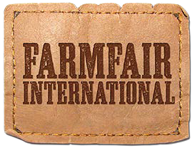

THE FARM FAMILY – Leaders in the Industry
The objective of the Farm Family Awards is to recognize outstanding farm families in an area north of Township 34.
The Farm Family Awards honor those who best exemplify the value of the family farm to our rural communities and society by being leaders in the industry.

Note: The Farm Family is considered as the immediate family currently involved in the family farm operation.
To be eligible for nomination, the Farm Family must meet the following criteria.
Please check off each characteristic as you confirm their validity.
The Farm Family must:
Be an active farm family unit where agriculture is the major source of income
ʹ

The Farm Family should:
Increase awareness of agriculture and maintain a high standard in their agriculture business Promote the agriculture community through involvement and rural citizenship
ʹ
ʹ
Be proactive in new agricultural technologies Act as a role model to the rural community
ʹ
ʹ
Be deserving based on equal recognition of agricultural and community involvement
ʹ

Please use the following to assess Farm Family Awards candidates. There are two criteria – THE FARM and THE COMMUNITY. Local conditions may suggest additional selection criteria, however these are the basic ones to be considered.
Each of the two criteria should receive equal weight when making a decision.

THE FARM FAMILY

Please ensure that the information is correct before submission and it is the direct contact information for the family.

Name of Farm or Farm Unit:
Last Name First Name
Primary Farm Partner 1:
Last Name First Name
Primary Farm Partner 2:
Last Name First Name
Primary Farm Partner 3:

E-Mail Address: Phone:

Mailing Address: City/Town:

Province: Postal Code:

Farm Website (if applicable): www.

Names of immediate family members actively engaged in the current farming operation:
Full Name: (First / Last) Relationship: Age: Gender: (M/F)

Be sure to consider the WHOLE FAMILY CURRENTLY FARMING, not just one member. Describe the following in detail. Additional information may be added on separate pages. DEADLINE: Monday, April 17, 2023
ABOUT THE FAMILY

Each year, farm families from North/Central Alberta communities are selected as the recipients of the Farm Family Awards. These awards recognize families who best represent the values of the family farm within their rural community.

Tell us about the family on this application form and how they demonstrate these values within your community.

Please provide a short family bio (300 words max). Please include this as a separate TYPED document.

Include information such as the history of the farming operation, length of time in the community, how the family acts as models in the community, and how the family spends time together.

THE FARM

Type of Farming Operation:

Scale of Operation (# of acres, head, etc.):

Use of modern farming practices & technologies (please give examples):

Soil conservation practices (please give examples):

Involvement in self-improvement programs (e.g. extension courses, 4-H programs, short courses, etc.):

General appearance / upkeep of farmstead (Buildings, Machinery, Yard/Driveway):

Any additional information:

THE COMMUNITY

ORGANIZATIONS
& SPECIAL PROJECTS

Please list family members involved, positions, responsibilities, and length of membership.
Include involvement in any business, government, agriculture, church, youth, or service clubs, associations, and groups.

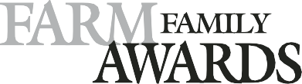
Nomination Form

THE COMMUNITY

AWARDS

Please list any awards won and include year and name of recipient. Include awards in relation to business, government, agriculture, church youth or service clubs, associations and groups.

ADDITIONAL INFORMATION
GATE SIGN
In the event that this family is chosen as a Farm Family Award recipient, please indicate the EXACT wording and correct spelling (Family or Farm Name) they would like on their gate sign. Only one line of print allowed. Print size will vary with the number of letters requested. Please select only one format.

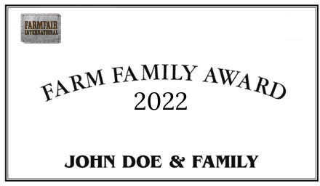
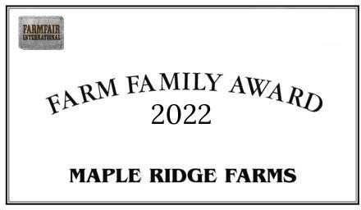
Example Gate Sign: FAMILY NAME Example Gate Sign: FARM NAME

OR

PLEASE PRINT GATE SIGN NAME AS IT WILL APPEAR ON THE SIGN:
Please ensure you have included all of the following information in this nomination form:

The Farm Family The Farm
The Community About the Family
I have attached a Family Bio (300 word maximum) Additional Information
COMPLETION CHECKLIST

I hereby certify that I have confirmed the above information and that it is true to the best of my knowledge.

Nominator Signature Date

CONTACT

Sarah Cairns
Phone: 780-524-7604
E-Mail: sarah.cairns@mdgreenview.ab.ca

Deadline: Monday, April 17, 2023
farmfairinternational.com

Please email the completed application
to Sarah Cairns, Landcare Coordinator,
Municipal District of Greenview

